**Exercises (Sweep and Loft Features)**

**Design and Model mug**

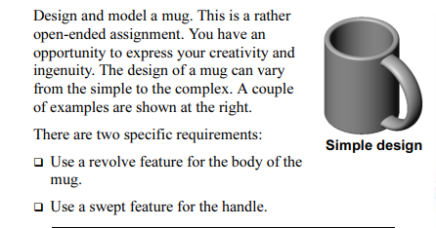

**Create a Bottle as shown in figure below:**

